Sales Insights Analysis
SQL and Power BI Project Report
Data source: MySQL "sales" database (Oct 2017 to Jun 2020)
Tools: MySQL 8, SQL, Power BI, DAX

1. Executive Summary
This project analyses roughly 148,000 sales transactions from a hardware retailer operating across 14 Indian cities. The data was stored in MySQL, cleaned and enriched with profit fields, queried with SQL, and presented in a three-page interactive Power BI dashboard.
The headline result is that revenue of about ₹984.8 million translates into a profit margin of only about 2.5%, and that both revenue and profit are concentrated in a few markets and customers. The largest market is not the most profitable one, and two markets lose money.

2. Objectives
- Measure total revenue and sales quantity, and track the trend over time.
- Identify the markets, customers and products that drive the business.
- Move beyond revenue and assess profitability by market and customer.
- Compare performance against the prior year and against a profit target.

3. Data Overview
The database contains five tables. Transactions form the fact table; customers, products, markets and the date table are dimensions.
Table | Rows | Description
transactions | 148,395 | Orders with product, customer, market, date, quantity, sales amount, currency, profit margin %, profit margin and cost price
customers | 38 | 19 Brick & Mortar and 19 E-Commerce customers
products | 279 | 191 Own Brand and 88 Distribution products
markets | 17 | City and zone (North, South, Central); 14 markets have sales
date | 1,126 | Calendar table with year, month name and a current-year date key

3.1 Raw versus cleaned data
Two database dumps were prepared. The first is the raw load; the second is the cleaned and enriched version used by the dashboard.
Aspect | db_dump (v1, raw) | db_dump_version_2 (v2)
Transactions | 150,283 | 148,395
Duplicate row groups | 281 | 0
Zero or negative sales rows | 1,611 | 0
Currency values | Trailing carriage return | Clean
Profit columns | None | Margin %, margin, cost price

4. Methodology
- Cleaning. Removed duplicate and zero or negative sales rows, stripped stray carriage-return characters from currency values, and added cost price and profit margin fields.
- SQL exploration. Filtered, joined and aggregated the data to answer questions such as revenue by year, month and market.
- Data model. Loaded the tables into Power BI as a star schema with transactions at the centre.
- Measures. Built DAX measures for Revenue, Sales Qty, Revenue LY, Revenue Contribution %, Profit Margin %, Profit Margin Contribution % and Total Profit Margin.

4.1 Sample SQL
SELECT SUM(t.sales_amount) AS revenue_2020
FROM transactions t
INNER JOIN date d ON t.order_date = d.date
WHERE d.year = 2020;

SELECT m.markets_name, SUM(t.sales_amount) AS revenue,
ROUND(100*SUM(t.profit_margin)/SUM(t.sales_amount),1) AS profit_margin_pct
FROM transactions t JOIN markets m ON m.markets_code = t.market_code
GROUP BY m.markets_name ORDER BY revenue DESC;

5. Dashboard Design
Page | Contents
Key Insights | Revenue and quantity KPIs; revenue and quantity by market; top 5 customers; top 5 products; revenue trend
Profit Analysis | Profit margin % and contribution % by market; revenue contribution %; top customers with profit metrics; total profit margin
Performance Insights | Revenue against last year with profit margin % overlay; drill-down by zone, market, customer and product; profit target parameter
Year and date slicers are available on every page, so each view can be filtered to a period. The screenshots below are filtered to 2020.

5.1 Key Insights
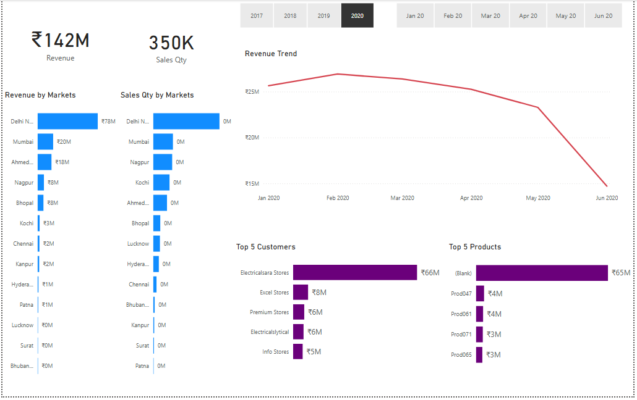

5.2 Profit Analysis
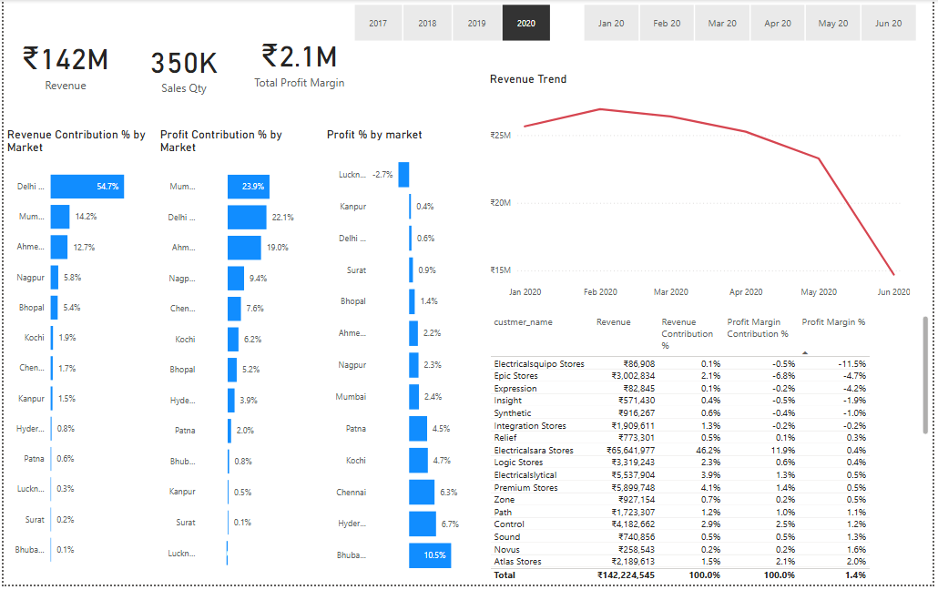

5.3 Performance Insights
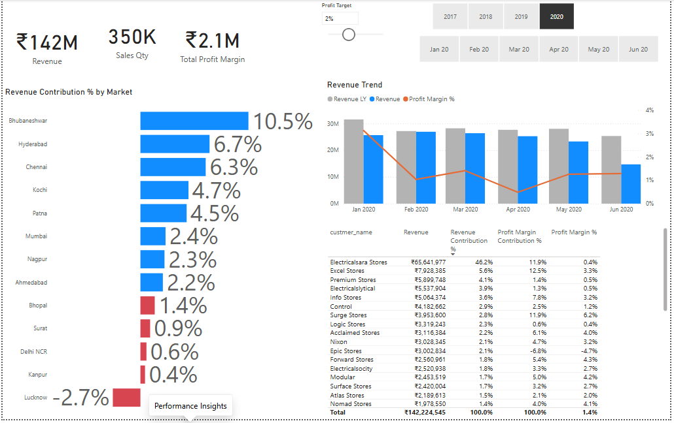
2020 snapshot (January to June): revenue ₹142.2M, 350K units and ₹2.1M profit, a 1.4% margin that is below the overall 2.5%. Delhi NCR contributes 54.7% of revenue but only 0.6% margin, and Lucknow loses money (-2.7%). Bhubaneshwar (10.5%), Hyderabad (6.7%) and Chennai (6.3%) lead on margin. Electricalsara Stores alone is 46.2% of 2020 revenue.

6. Findings

6.1 Revenue
Total revenue is about ₹984.8 million on 2.43 million units. Revenue peaked in 2018 and declined in 2019. 2020 covers January to June only.
Year | Revenue (₹ million)
2017 (Oct to Dec) | 92.9
2018 | 413.7
2019 | 336.0
2020 (Jan to Jun) | 142.2

Brick & Mortar customers contribute about ₹744.5 million (76%) and E-Commerce about ₹240.3 million (24%).
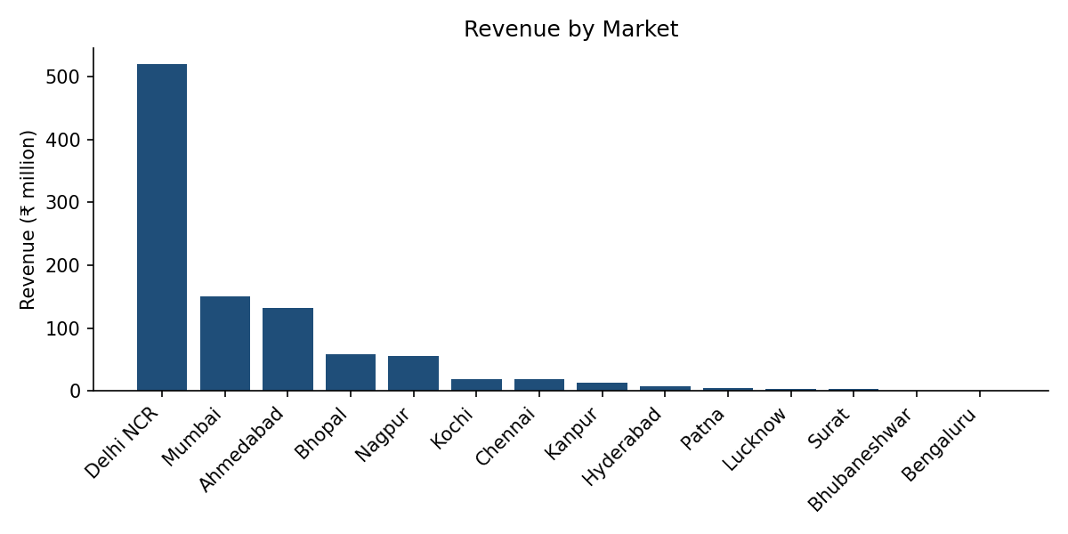
Delhi NCR generates about 53% of revenue, followed by Mumbai (15%) and Ahmedabad (13%). The top three markets account for over 80% of sales.

6.2 Customers and products
Top customers | Revenue (₹ million) | Share of revenue
Electricalsara Stores | 413.3 | 42.0%
Electricalslytical | 49.6 | 5.0%
Excel Stores | 49.1 | 5.0%
Premium Stores | 44.9 | 4.6%
Nixon | 43.9 | 4.5%

Electricalsara Stores alone accounts for 42% of revenue, a significant dependency. By transaction product code, the top sellers are Prod318 (₹69.0M), Prod316 (₹60.9M) and Prod324 (₹41.5M). Note that the dashboard cannot show these names because they are missing from the products table (see section 7).

6.3 Profitability
Total profit margin is about ₹24.7 million on ₹984.8 million of revenue, an overall margin of about 2.5%. About 46% of transactions (68,501 rows) were sold at a loss.
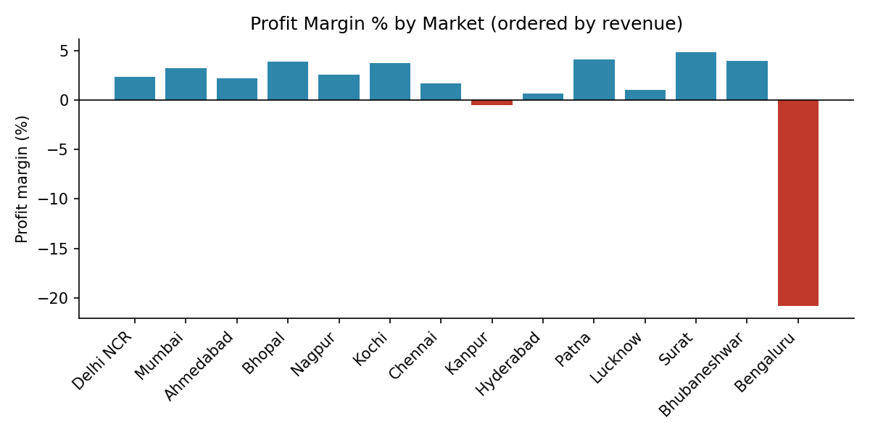
Market | Revenue (₹M) | Profit (₹M) | Margin %
Delhi NCR | 519.5 | 11.95 | 2.3%
Mumbai | 150.1 | 4.87 | 3.2%
Ahmedabad | 132.3 | 2.85 | 2.2%
Bhopal | 58.6 | 2.29 | 3.9%
Nagpur | 55.0 | 1.41 | 2.6%
Kochi | 18.8 | 0.70 | 3.7%
Chennai | 18.0 | 0.30 | 1.7%
Kanpur | 13.6 | -0.07 | -0.5%
Bengaluru | 0.4 | -0.08 | -20.8%

Delhi NCR delivers nearly half of all profit, but at a margin below the average. Smaller markets such as Surat (4.9%), Patna (4.1%) and Bhopal (3.9%) earn better margins on much lower volumes. Bengaluru and Kanpur are loss-making.

7. Data Quality Observations
- The products table covers only Prod001 to Prod279, but 54,599 transactions (about ₹469M, 48% of revenue) use Prod280 to Prod339. These appear as (Blank) in Power BI, so the Top 5 Products chart shows one blank bar (₹65M in 2020). The fix is to add the missing product codes to the products table.
- The product_type field still contains trailing carriage-return characters and should be trimmed.
- Two USD transactions (₹750 in total) are not converted to INR; the effect is immaterial.
- Bhopal appears under two market codes (Mark007 and Mark013).
- Mark097 (New York) and Mark999 (Paris) have no transactions.
- The customers table column custmer_name is misspelled in the source schema.

8. Recommendations
- Reduce customer concentration: build account plans to grow the next 10 customers, since one customer holds 42% of revenue.
- Review pricing and discounts in Delhi NCR. A one-point margin gain on 53% of revenue would add roughly ₹5.2 million of profit.
- Investigate loss-making markets (Bengaluru, Kanpur) and the 46% of transactions sold below cost before committing more volume.
- Explore growth in high-margin markets such as Surat, Patna and Bhopal.
- Complete the products dimension so that product-level analysis in the dashboard covers all revenue, not just 52% of it.
- Investigate the 2019 revenue decline against 2018 using the Revenue LY view.

9. Conclusion
The analysis shows a business with healthy revenue but thin margins and heavy dependence on one city and one customer. The dashboard gives decision-makers a single place to monitor revenue, profitability and year-over-year performance, and to find where margin is being lost.

